**Project Task List 3**

* **Team Name**: Eagles
* **Team Members:** Kenneth Mendoza

Yash Gandhi

Olga Neyezhsal

Lawrence Tillson

Enrina Wilms

* **Roles and Responsibilities:**

Team Lead:  **Yash Gandhi**(Team lead acts as

the bridge between members of the

team, creates the general blueprints

for the collection of technologies

that will support the chosen web site

technology framework, including

content management. )

Lead Designer: **Enrina Wilms** (Creates the

overall look and feel for the web

site, establishing the site

typography,

visual interface design, color, page

layout details, photography,

illustration.)

Documentation Manager: **Lawrence Tillson** (To record

minutes at meetings, organize our

documents, and present them in a

meaningful way. )

Information Architecture

and User Interface Designer: **Kenneth Mendoza**

(Organizes and categorizes web site structure and content, design and planning phases of the project, content structure across the site, and site architecture diagrams that explain the overall site planning to the web team members. )

Editor:  **Olga Neyezhsal** (The editor tests

workflows,internal and external

links,writes content and editorial

quality of the finished site. )

* **Project Name:**

Stock Market

* **Description:**

The Platform will help users to manage their investment portfolio by providing real time data from the stock market. The web application will have different facilities such as Creating/Managing portfolio, Creating watchlist, Gainers and Losers for the day, and projection chart to let user see the future investing value of their portfolio. Furthermore, users can interact with each other to create trade ideas and share thoughts of a stock. They can also share their recent trade and it will have comment section to discuss that particular trade among other users.

* **Target audience and objective:**
  + Investors are the target audience
  + Our Objective is to make investing organized and easy to do.
* **Technical considerations:**
* Languages: HTML, CSS, Java Script, PHP,
* Libraries: jQuery,
* Database: MySQL
* API:TBD
* **Deliverables:**

The following are the deliverables for Stock market web application:

1. The Homepage will have a minimalist design.
2. The wireframes will be finalized during week 5.
3. The mockups will be finalized the following week.
4. We aim to design a site that encourages users to revisit the site daily, and we strive to do this through the following features .
5. Our users can post their recent trade and share it among other users. it will contain comment section so other users can discuss the idea behind that trade.
6. Our users can search for particular stock and our site will return data about that stock along with some news. Users can also add the stock to their portfolio or watchlist.
7. We will have a projection chart that’s shows the future value of a user’s investment depending on what they have in their portfolio.
8. Users will get a feature to create watchlist, to help them keep track on their selected stocks.

* **Timeline:**

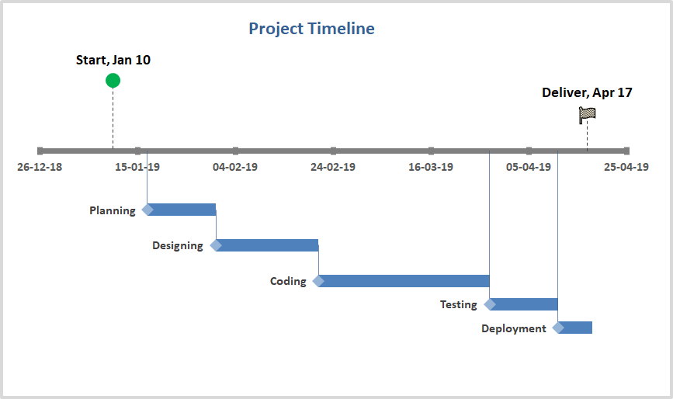

* **Project lifecycle overview:**

Phase 1: Planning ( 2 Weeks )

This phase consists of following tasks

1. Requirement gathering.
2. Requirement elaboration and negotiation.
3. Project scope finalization.
4. Collecting data about API’s

Phase 2: Design ( 3 Weeks )

This phase consists of following tasks

1. Creating wireframes.
2. Getting design layouts ready

Phase 3: Coding ( 5 Weeks )

This phase consists of following tasks

1. Development of MVP.
2. Creating Database.
3. Development for individual features.
4. Unit testing for individual features
5. Merging of all individual features

Phase 4: Testing ( 2 Week )

This phase consists of following tasks

1. Testing of Web Application

Phase 5: Deployment ( 1 week )

This phase consists of following tasks

1. Hosting of web application
2. Testing

* Communication Plan:
* development server: XAMPP, MAMP
* documentation:Google Drive
* version control: GitHub